# Removing Friction in Patient Journeys: A District Implementation Model leveraging technology solutions for health services delivery

## Background

Over the years, several Indian states have taken significant steps towards achieving **universal access to equitable, affordable, and quality healthcare services**, by extending a range of health schemes/ programs that provide access to primary, secondary and tertiary care through public and private[1] health facilities. Recent research from India reveals the multitude of challenges involved in the act of seeking care and navigating the healthcare delivery systems in India across public and private alike. This research shows how the absence of reliable and **accessible points of first contact for primary care**, and more broadly, an opaque and unresponsive health system amplifies these challenges and results in citizens running from pillar to post, taking wrong turns, and becoming disappointed, frustrated and sometimes impoverished and a suboptimal user experience. We contend that one of the key problems driving this experience is the opacity of the health systems and we call it the ‘Observability Challenge’.

While on one hand, this complex journey leads to a **delay in receiving the required care** and contributes to **increased out-of-pocket expenditure (OOPE)**, on the other hand, the multitude of **government schemes remain under-utilized** due to low levels of awareness regarding eligibility and process of availing benefits.

These challenges offer an unprecedented opportunity to radically transform the healthcare seeking experience that are patient-centric and friction-free, through improved co-ordination of information and service delivery.

## A vision for Integrated Healthcare Delivery

This is possible through a healthcare delivery system that is:

1. ***Responsive and empathetic to patient needs***byhelping them reliably navigate to credible, appropriate, and affordable care
2. ***Comprehensive***in its ambit, covering all treatment from primary through tertiary care, diagnosis, transportation, and medicines
3. ***Of high reliability and quality,*** even in remote areas
4. ***Based on accurate and complete information flow***through the chain of care

This could be achieved through the following building blocks:

1. A **District-level triaging centre or an integrated healthcare delivery hub** that registers healthcare seekers’ requests, understands their needs, and responds by providing information on and access to all the services and provides outreach based on family health register (through assured appointment/ booking), including diagnostics, healthcare services (primary through tertiary), medicines and transportation (including emergency transportation services made available through ambulance). This can be achieved through the integration of health services extended through various touchpoints of the health system and enabling information exchange by further strengthening the existing state-run health helpline or call centres.
2. **Integrated machine-readable electronic health record (EHR) or patient health record (PHR) system** across all facilities to enable ‘in-process’ responsive appropriate care, along with post-facto analysis, quality audit and capacity building. This could be enabled through the government’s implementation of Ayushman Bharat Digital Mission (ABDM), which provides Ayushman Bharat Health Accounts (ABHA) to all the healthcare seekers and can also enable seamless information exchange between the healthcare facilities, with consent from the healthcare seeker.
3. **Aggregated analysis of functional units** (departments, facilities, geographies) on key performance parameters such as availability, quality, affordability and appropriateness of diagnosis and care in line with Standard Treatment Guidelines (STGs). These parameters could be assessed in real-time based on the ‘in-process’ information captured against the EHR and post-facto information based on the feedback gathered from the healthcare seeker on the availed services. The analysis could be made available to the functional units themselves and to the concerned authorities to promote ‘competition’ among these functional units and to enable performance and quality enhancement.
4. **Geographic analysis of health services’ requirements and usage** to design targeted outreach interventions (specifically for preventive care) and to enable data-backed decision making for health infrastructure investments, thereby strengthening the overall health system. This will be powered by the information collected by the integrated healthcare delivery hub and therefore will only become more robust with time. This information can go a long way in proactively planning for important **preventative health** measures that provide the greatest return on government investment.

The figure below illustrates such a vision.

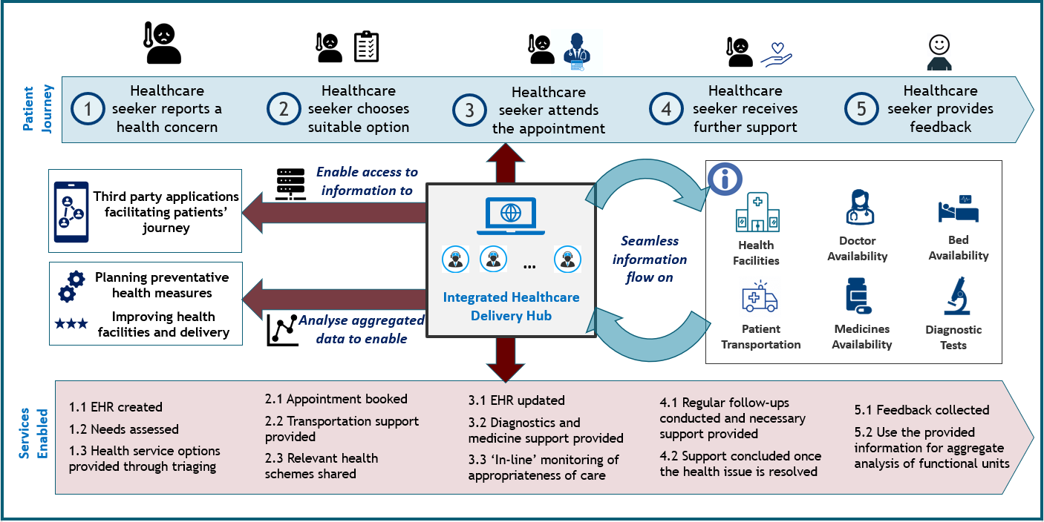

Figure : Vision of integrated healthcare delivery

## Envisaged outcomes from the implementation of the vision

There is growing global evidence that patient navigation interventions (enabled through community health workers or patient navigators) can be effective in boosting access to health service[2],[3], improving chronic disease management[4],[5], and enhancing the overall health and wellbeing of population (especially vulnerable or disadvantaged groups[6]). This vision, while leveraging the benefits of a patient navigation intervention, takes the next logical step of integrating the provision of health services through seamless exchange of information across the patient’s healthcare seeking journey with the help of an Integrated Healthcare Delivery Hub. This added layer of health information exchange powered by multiple data registries (such as patient records, OPD calendars, beds’ and doctors’ availability across health institutions, patient transportation options, pharmacies and diagnostic facilities, among others) will provide an ecosystem that can further streamline the access to quality care and enable its coordinated delivery.

For instance, once the appointment booking is enabled (through Integrated Healthcare Delivery Hub), its reach can be further amplified by extending (through APIs) information on doctors’ availability, OPD calendars, and bed availability to other third-party applications and platforms (accessible directly by healthcare seekers or advisors) to enable direct appointment booking or bed reservation at facilities against the healthcare seeker’s EHR. As an analogy, this is similar to a traveller booking train tickets directly from the train station or by visiting railways’ website or calling their call centre or through applications like MakeMyTrip, Yatra, and such others. Another way in which this information could be utilized is to analyse aggregated patient information to design and implement targeted interventions (including outreach campaigns and behaviour change communication, especially for preventive care) catering to specific geographies, demographics, or disease areas, as necessary.

Therefore, effective implementation of this vision can lead to an integrated healthcare delivery system which:

1. Handholds the patient to the care that they need
2. Is responsive in real time to ensure delivery of appropriate quality care
3. Is agnostic to source of delivery (private vs. public)
4. Is comprehensive (from primary to tertiary care)
5. Relies on accurate and complete information through the chain of care

Once implemented in its entirety, the vision would enable

1. **Optimization of case load across public health facilities** through better assessment of healthcare seekers’ needs and navigating them to the appropriate health facility.
2. **Efficient deployment of resources** (both for outreach efforts and for improving health facilities and delivery) based on insights derived from aggregated data on healthcare seekers’ needs
3. **Improving utilization of government health schemes** (including tele-consultation services extended through e-Sanjeevani) by providing relevant information to the healthcare seekers about the schemes and the process or steps to avail them
4. **Strengthening the health system** by enabling ‘competition’ between the healthcare facilities to improve the availability, quality, affordability, and appropriateness of the health services
5. **Increasing trust (of citizens) on public healthcare** **system** through the provision of assured appointments and quality healthcare services.

1.
2. Ali-Faisal SF, et al. The effectiveness of patient navigation to improve healthcare utilization outcomes: A meta-analysis of randomized controlled trials. Patient Education & Counselling. 2017; 100(3): 436–48. DOI: <https://doi.org/10.1016/j.pec.2016.10.014>
3. Javanparast S, et al. Community health worker programs to improve healthcare access and equity: Are they only relevant to low- and middle-income countries? International Journal of Health Policy and Management. 2018; 7(10): 943–54. DOI: <https://doi.org/10.15171/ijhpm.2018.53>
4. Kim K, et al. Effects of community-based health worker interventions to improve chronic disease management and care among vulnerable populations: A systematic review. American Journal of Public Health. 2016; 106(4): e3–e28. DOI: <https://doi.org/10.2105/AJPH.2015.302987>
5. Mistry SK. et al. Community Health Workers as Healthcare Navigators in Primary Care Chronic Disease Management: a Systematic Review. J Gen Intern Med. 2021 (Epub ahead of print). DOI: <https://doi.org/10.1007/s11606-021-06667-y>
6. Thomas L et al. Health service brokerage to improve primary care access for populations experiencing vulnerability or disadvantage: a systematic review and realist synthesis. BMC Health Services Research. 2019; 19(1): 269. DOI: <https://doi.org/10.1186/s12913-019-4088-z>